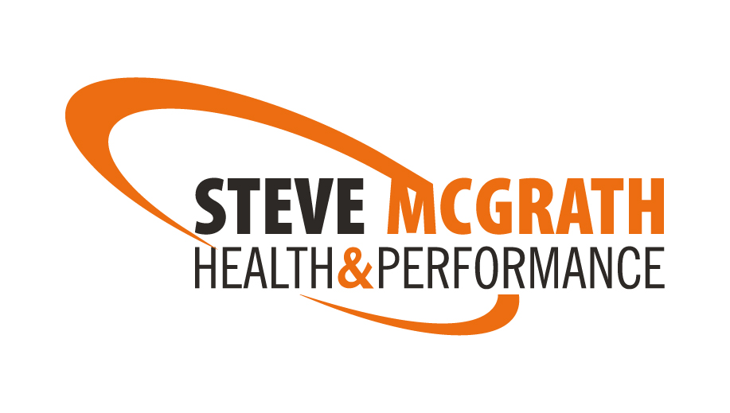
7 nutrition habits

- SLOW DOWN YOUR EATING SPEED
When you sit down to eat remember it’s not a race. Take your time and relax. It should take 15-20 minutes to eat a meal. Stop eating when you are 80% full. It takes 20 minutes for your body to register that it is full. Naturally reduces the amount of calories that you consume and is easy on your digestive system.

- IS THERE PROTEIN IN THE MEAL YOU ARE ABOUT TO EAT?
Are you about to eat protein with your meal? If not, you should be. Protein makes you feel full and boosts your metabolism just by eating it (this is called the THERMIC EFFECT OF FOOD- TEF).
Woman should be eating 1 palm-sized portion at every meal.
And men should be eating 2 palm-sized portions at every meal.

- WHERE ARE YOUR FRUIT AND VEGETABLES?
One serving is approximately 1 fist-sized portion. Aim for 8-12 portions a day (mostly veg). Adding a few portions into each meal is the easiest way to hit this target- omellettes, stir-fry’s, salads, smoothies, etc.

- EARN YOUR CARBS BY EXERCISINGH
If you are trying to lose weight and you have not just worked out, skip the starchy carbs- rice, cereals, sweet potato, etc. If have just worked out, a fist-sized portion of carbs should be eaten.

- EVERYONE NEEDS HEALTHY FATS
You need healthy fats in your food plan. Eggs, fish, meats, olives, nuts, seeds, coconut oil and Omega 3 fish oils are all great sources of good fats. Healthy fats boost your metabolism, burn body fat, help fight disease, improve brain function and so much more.
Spread your healthy fat consumption throughout your day.

- DRINK A MINIMUM OF 2 LITRES OF WATER A DAY
Everybody should be drinking 2 litres of water daily. If you find it hard to drink on its own, add or squeeze fresh lemon or lime into it. Water is essential to hydrate the body and to maintain concentration throughout the day. Drink 2 cups of green/white tea daily to increase water intake and get some healthy anti-oxidants as well.

- DO YOU NEED NUTRITIONAL SUPPORTS?
If you find you are not meeting your nutritional needs through your daily food intake, utilize nutritional supports to fill in the gaps. Working long days / night shifts, travelling with work can all lead to us not getting adequate nutrition into our body. Nutritional supports do not have to be long term, you only need it when you don’t hit your nutrition goals through food.

Examples of nutritional supports are multi-vitamins, Omega3 fish oils and protein powder.

NOTE: THERE ARE LOTS OF GREAT HABITS THAT WE CAN BUILD INTO OUR NUTRITION AND LIFESTYLE AND ARE NOT LIMITED TO THOSE MENTIONED ABOVE. THE 7 NUTRITIONAL HABITS WILL LAY A GREAT FOUNDATIONT FOR YOUR HEALTH AND PERFORMANCE AND MAKE SUBSEQUENT CHANGES A LOT EASIER TO IMPLEMENT LATER ON.

